Aim: To obtain the best fit line over single feature scattered datapoints using Linear Regression
IDE: Google Colab

Theory:

Linear regression is a method for determining the best linear relationship between two variables X and Y. If variables X and Y are uncorrelated, it is pointless embarking upon linear regression. However, if a reasonable degree of correlation exists between X and Y then linear regression may be a useful means to describe the relationship between the two variables. The usual approach is to use the least-squares method, which minimizes the squared difference between the actual data points and a straight line. Let [x_{i},y_{i}], i = 1,2,3,….,N be the N pairs of data values of the variables X and Y. The straight-line relating X and Y is y = mx + c, where m and c are the gradient and constant values (to be determined) defining the straight line. Thus, y(x_{i}) - y_{i} is the difference between the line and data point i (see Fig. 1). Taking all the data points, we seek values of m and c that minimize the squared difference SD.
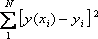

This is achieved by calculating the partial derivatives of SD with respect to m and c and finding the pair [m,c] such that SD is at a minimum.
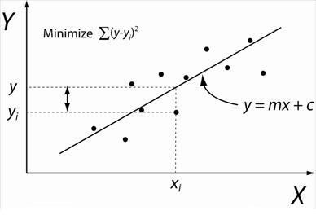

Figure 1: Illustration of Linear Regression. Linear least squares regression, the idea is to find the line y = mx + c that minimizes the mean squared difference between the line and the data points

Batch Gradient Descent:
Gradient Descent is an optimization algorithm used for minimizing the cost function in various machine learning algorithms. It is basically used for updating the parameters of the learning model. Batch gradient descent which processes all the training examples for each iteration of gradient descent. But if the number of training examples is large, then batch gradient descent is computationally very expensive.
Let m be the number of training examples. Let n be the number of features.

Algorithm for batch gradient descent :
Let h_{θ}(x) be the hypothesis for linear regression. Then, the cost function is given by:
Let Σ represents the sum of all training examples from i=1 to m.
J_{train}(θ) = (1/2m) Σ( h_{θ}(x^{(i)}) - y^{(i)})²
Repeat {
θj = θj – (learning rate/m) * Σ( h_{θ}(x^{(i)}) - y^{(i)})x_{j}^{(i)}
For every j =0 …n
}
Where x_{j}^{(i)} Represents the j^{th} feature of the i^{th} training example. So if m is very large(e.g. 5 million training samples), then it takes hours or even days to converge to the global minimum.That’s why for large datasets, it is not recommended to use batch gradient descent as it slows down the learning.

Pre Lab Exercise:

a. Explain the meaning of linear regression

Linear Regression is a supervised machine learning algorithm used to model the relationship between a dependent variable (output) and one or more independent variables (input) using a straight line equation.

b. Write three applications of linear regression

House price prediction based on size, location etc.

Sales forecasting based on past trends

Student marks prediction based on study hours

c. Write three advantages of linear regression

Simple and easy to understand

Fast training and prediction

Works well for linearly related data

d. Write three limitations of linear regression

Assumes linear relationship between variables

Sensitive to outliers

Not suitable for complex or nonlinear data

Methodology:
- Load the basic libraries and packages
- Load the dataset
- Analyse the dataset
- Pre-process the data
- Visualize the Data
- Separate the feature and prediction value columns
- Write the Hypothesis Function
- Write the Cost Function
- Write the Gradient Descent optimization algorithm
- Apply the training over the dataset to minimize the loss
- Find the best fit line to the given dataset
- Observe the cost function vs iterations learning curve

Program (Code):
import numpy as np
import pandas as pd
import matplotlib.pyplot as plt

url = "https://raw.githubusercontent.com/selva86/datasets/master/Advertising.csv"
df = pd.read_csv(url)
print("First 5 rows:\n", df.head())
print("\nDataset Info:\n")
print(df.info())
print("\nStatistics: \n", df.describe())
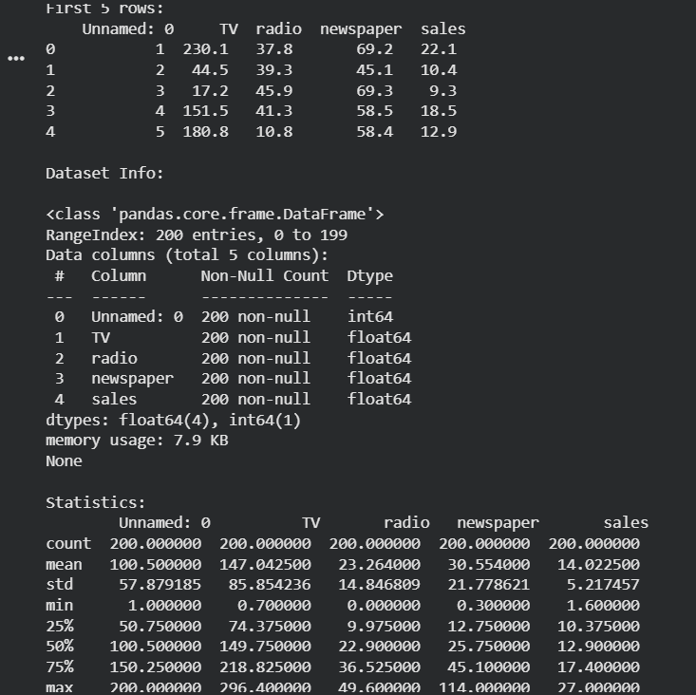
#Use only TV advertising for simple linear regression
x=df['TV'].values
y=df['sales'].values

#Normalize data (optional but good practice)
x=(x-x.mean())/x.std()
plt.scatter(x,y)
plt.title("TV vs Sales")
plt.xlabel("TV (Normalised)")
plt.ylabel("Sales")
plt.show()

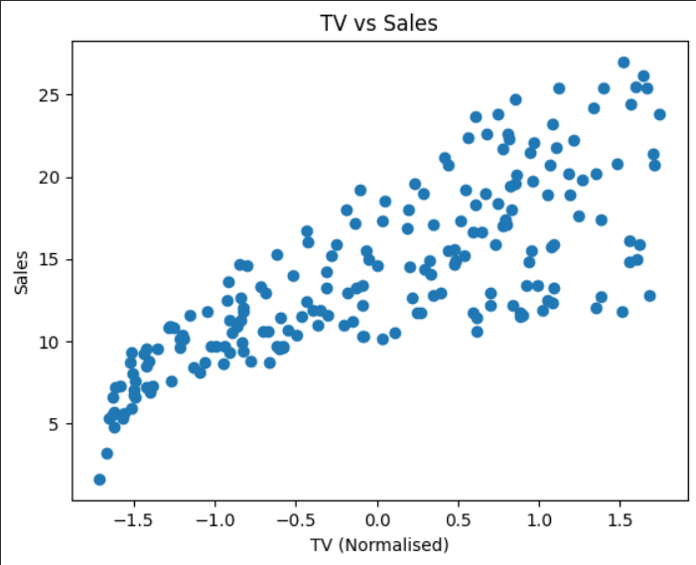

x=x.reshape(-1,1)
m=len(y)

#Add bias term (column of 1s)
x_b=np.c_[np.ones((m,1)), x]
def hypothesis(x, theta):
return np.dot(x, theta)
def cost_function(x,y,theta):
m=len(y)
return (1/(2*m)) * np.sum((hypothesis(x,theta)-y)**2)
def gradient_descent(x,y,theta,lr,iterations):
m=len(y)
cost_history=[]

for i in range(iterations):
gradients=(1/m)*np.dot(x.T, (hypothesis(x, theta)-y))
theta=theta-lr*gradients
cost_history.append(cost_function(x,y,theta))
return theta, cost_history
#initial parameters
theta=np.zeros(2)
learning_rate=0.01
iterations=1000

theta, cost_history=gradient_descent(x_b,y,theta,learning_rate, iterations)
print("\nBest parameters(theta):",theta)
y_pred=hypothesis(x_b, theta)

plt.scatter(x,y)
plt.plot(x, y_pred, color='red')
plt.title("Best Fit Line")
plt.xlabel("TV (Normalised)")
plt.ylabel("Sales")
plt.show()

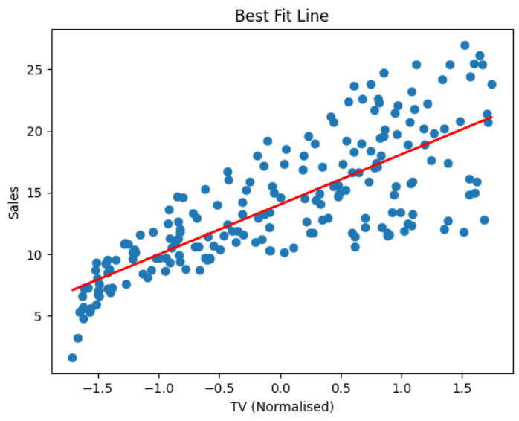
plt.plot(range(iterations), cost_history)
plt.title("Cost Function vs Iterations")
plt.xlabel("Iterations")
plt.ylabel("Cost")
plt.show()
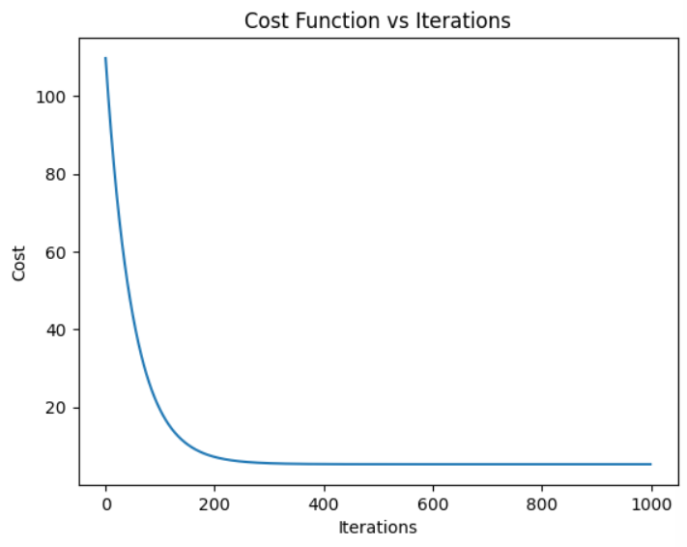

Observation and Result Analysis:

Nature of the dataset

The dataset consists of numerical (continuous) values for input and output variables.
It is a supervised dataset, where the target value is already known.
The data shows a linear relationship between independent variable(s) and dependent variable.
Example: Study hours vs marks, area vs house price.

b. During Training Process

During training, the linear regression model:

Identifies relationship between input (X) and output (Y)

Calculates slope (m) and intercept (b)

Fits the best possible straight line that minimizes error

Uses error minimization method such as least squares

The model learns the pattern from given training data.

c. After the training Process

After training:

The model forms an equation of a straight line

This equation is used to predict output for new input values

Accuracy is evaluated using measures like Mean Squared Error (MSE) or R² score

The model can estimate unknown values based on learned relationship

The trained model helps in predicting continuous values efficiently.

Post Lab Exercise:
- What are the major assumptions considered in linear regression
Linear regression assumes that the relationship between independent variables and the dependent variable is linear. It also assumes that observations are independent of each other and that the variance of errors remains constant (homoscedasticity). The residuals (errors) are expected to be normally distributed, and independent variables should not be highly correlated with each other (no multicollinearity). Additionally, the model assumes there are no extreme outliers that can significantly affect the regression results.
- Why MSE is used instead of MAE for calculating the loss function
Mean Squared Error (MSE) is commonly used instead of Mean Absolute Error (MAE) because it is differentiable and easier to optimize using gradient descent. MSE squares the error values, which penalizes large errors more heavily, helping the model achieve better accuracy. It also provides a smooth gradient, allowing faster and more stable convergence to the optimal solution.

- How can the behaviour of outliers be understood while dealing with the unseen dataset
Outliers are extreme values that differ significantly from other data points and can strongly affect model performance. Their behaviour can be understood by analyzing residuals, where unusually large errors may indicate the presence of outliers. Visualization methods like scatter plots or box plots also help identify abnormal values. Techniques such as Z-score or IQR can be used to detect outliers mathematically. Since outliers can reduce prediction accuracy on unseen data, they should be carefully analyzed or handled before building the model.

- Derive the Normal Equation for the Linear Regression.
The Normal Equation is used to directly calculate the optimal parameters of a linear regression model without using gradient descent. It is obtained by minimizing the Mean Squared Error cost function and solving it analytically. This method gives the best-fit parameters that minimize the difference between predicted and actual values.
Normal Equation:
$$θ=(X^{T}X)^{-1}X^{T}y$$

